<https://www.plugsurfing.com/home>

<https://www.plugsurfing.com/map?lang=en&location=Berlin,%20Germany>

Hat eine interaktive Map.

<https://www.plugsurfing.com/map?location=Switzerland&lang=en>

Example der Daten einer einzelnen Ladestation: <https://www.plugsurfing.com/map?station=100491&lang=en&location=Brugg%20District,%20Switzerland>

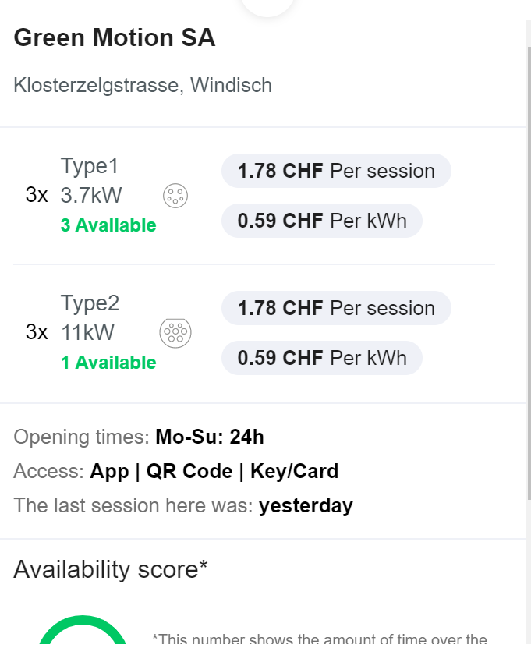

Es scheint eine API zu geben: <https://mclouddocs.plugsurfing.com/index.html#>

Die ist aber nicht frei zugänglich.

“Abos”: Charging key/**Charging card**

**Plugsurfing** is an E-mobility Service Provider. Using either our app or our RFID Charging Key, you have access to the biggest charging network in Europe. There is no subscription cost: you only pay when you charge.

<https://plugsurfing.freshdesk.com/en/support/solutions/articles/7000027261-how-does-plugsurfing-work->